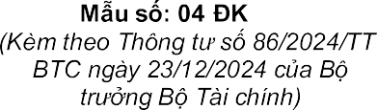
- -TCT
-

-
-

TAX REGISTRATION FORM
(Use for contractor/sub-contractor/management board)

Kê khai Kê khai-

Name of contractor/ sub-contractor/management board
Tax agent (if any)
2a. Tên (Name)
ngày
Tax agent contract: Number Date
(Nationality):

Fax: Email:

Address of the head office
Nam
Address of management office in Vietnam
Street number, Street name or Commune
Ward
District
Province/City
: Fax:
Email:

Nam
Business licence in Vietnam
Number
Date
Granted by


Contract for Contractor/Sub-Contractor operation in Vietnam
Number
Date

Signed with

Tax payers identification number in Vietnam (if any)

Contract objectives

Location of according to the contract

Contract duration
Không
No
Có
Yes
c ngoài
Do you have sub-contractor?

:
Information of representative of contractor (or sub -contractor)
Name of representative of contractor (or sub -contractor)
Possition
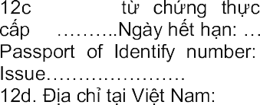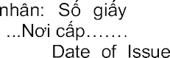 | h
Address of representative of contractor (or sub -contractor) in Vietnam
Street number, Street name or Commune
Ward
District
Province/City
12e. Thông tin khác:
Others
Email: Website:

GTGT  VAT calculation method | Deduction method | Directly method

TNDN  CIT calculation method | Doanh thu, chi phí Revenues, expenses | Directly method

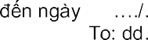

Finacial year

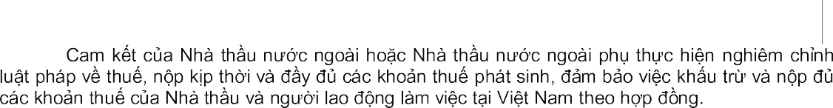
Attachments
Contractors, sub-contractors commit to observe all tax laws, timely and fully pay taxes, ensure to withhold and pay full tax dues of sub-contractors and employees involved in the contract in Vietnam.

Staff of tax agent  Name  Certificate number |     Representative of contractor (or sub -contractor)  (Signature)

- -TCT GUIDANCE FOR DECLARATION
Contractor/sub-contractor/management board select one of the appropriate boxes before declare detail information, as follows:
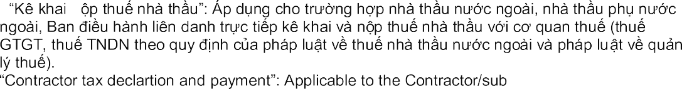
- -n

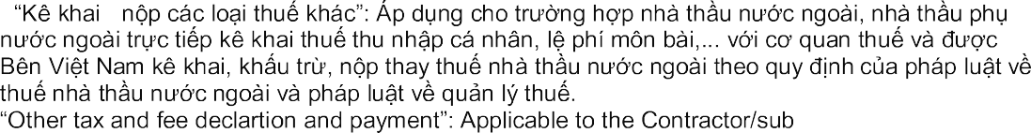
-contractor/management board direct contractor tax declartion and payment and submit to tax department (VAT, CIT in accordance with the conttactor tax law and tax managment law).
- -

-
contractor/management board direct PIT, other fees declartion and payment a nd submit to tax department and Vietnamese parties deduct and pay on behalf of contractor/sub -contractor about VAT, CIT in accordance with the contractor tax law and tax managment law.
danh:
Name of contractor/sub-contractor/management board: Write full name (including abbreviated name) of contractor or sub-contractor or management board doing business in Vietnam under the form not stipulated in the Law of Invesment.
Information of Tax agent: Write name, TIN, con tract (number, date).
o
Nationality: Fill in clearly the nationality of the contractor/sub -contractor/management board.
chính.
Address of head office:
If contractor/sub-contractor is an idividual, fill in address, telephone number, fax number of residency.
If contractor/sub-contractor is an organisation or company, fill in address, telephone number, fax number of the head office.
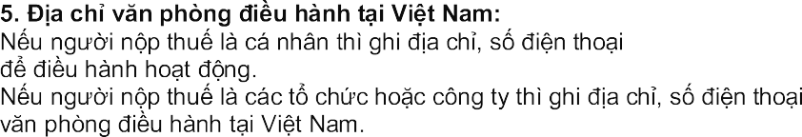
Address of Management office in Vietnam:
If contractor/sub-contractor is an idividual, fill in address, telephone n umber, fax number of the individual residing in Vietnam to do business.
If confractor/sub-confractor is an organisation or company, fill in address, telephone number, fax number of the management office in Vietnam.
t Nam:
Business license in Vietnam:
Based on the business license granted by the competent Goverment authority , fill in the relevant items in the form (if any).

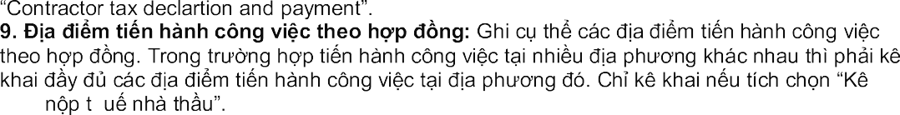
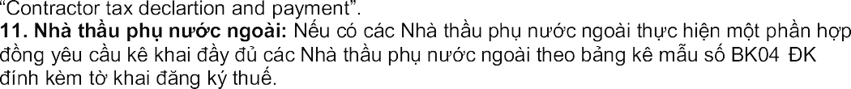
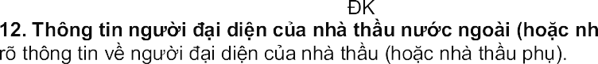
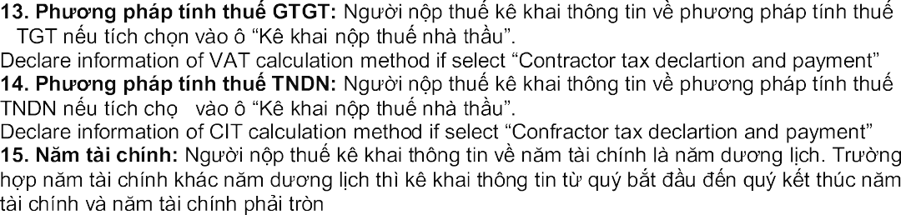
12 tháng.
Declare information of finacial year (From ... to ...) is calendar year. If finacial year is different from calendar year, declare information is from quarter to quarter and finacial year must be full 12 months.
Attachments: List all documents attached to the Tax Registtation Form thông tin này.
Staff tax agent: Staff tax agent derclare name and certificate number on this area if tax agent
derclare onbehalf of contractor/sub-conttactor
-
n
-
G
- -TCT

Do you have sub-confractor: If there are sub-contractors taking part in the contract, please declare fully in the Sub-contracor form of BK04 - -TCT declare attached.
à Ghi

Declare information of representative of contractor (or sub -contractor)
Location of business according to the contract: Declare each operation location of the contract concretely. In case of doing business at many different location, contractor/sub -conttact has to declare fully the location to do business if sele

-
Contract duration: Fill inclearly contract duration from month, year to month, year if select
h
khai-
ngoài:
-
Contract for contractor/sub-contractor operation in Vietnam: Based on the signed contract, fill in the

g
-
Contract objectives: Declare each operation objective of the contract concretely if select

